Planting Native Plants for Birds – A New Primer
2020 Bringing Nature Home Series – March 14, 2020
Handout from presenter John Barber (jcbarber27@gmail.com)

Simple actions to take now:
- Provide a wide variety of native trees, shrubs, grasses, sedges, ferns, perennials, and leaf litter
- Provide clean and safe water year-round
- Never use insecticides or rodenticides
- Never permit cats outdoors – and remove strays

Plant natives now. Then plant more native plants.

Construct a five-layer yard:
- Trees for canopy
- Understory trees (dogwood, pawpaw, sassafras, hawthorn…)
- Shrubs (remove invasives such as privet, barberry, forsythia, burning bush)
Perennials (mass species in clumps)
- Leaf litter, logs, partially-buried stones, patches of bare earth, small sand piles
- Use straight species or as close to straight species as possible

Seasonal Choices for Shrubs and Tall Understory Plants
SUMMER FOOD
SPRING FOOD NEST SITES & MATERIALS AUTUMN FOOD WINTER FOOD & SHELTER
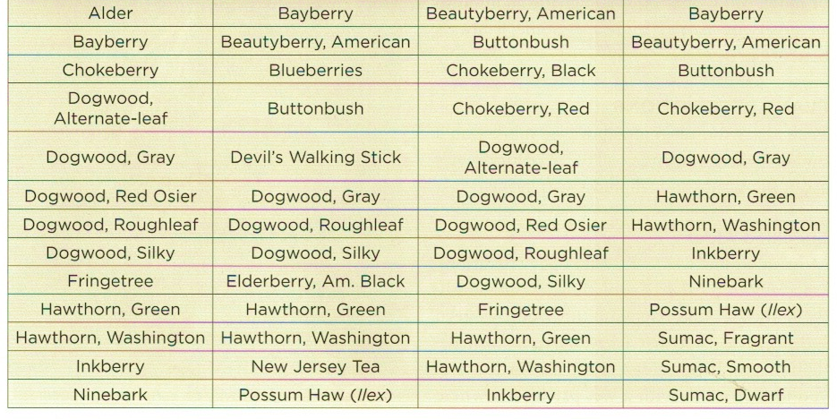

Chart above from Sorenson, Planting Native to Attract Birds to Your Yard:
“The aim here…is to provide for birds in all four seasons –
bugs, buds, and shelter in spring,
bugs, nest sites, and nest materials in summer,
bugs, fruit, nutritious berries, and shelter in autumn, and
seeds, berries, and shelter in winter.”
Buy plants (neonicitinoid-free certification, not a cultivar, as local as possible – ask, ask, ask)
Do not dig up plants in the wild!
Propagate and trade plants – collect seeds or purchase from Ohio Prairie Nursery

Sellers:
Nature Center at Shaker Lakes – May 9, 2020 (pre-orders due by 4/17)
North Chagrin Nature Center – May 9, 2020
Holden Arboretum – May 15 and 16, 2020
Avalon Gardens, Chardon, Ohio
Scioto Gardens, Powell, Ohio
Natives in Harmony, Marengo, Ohio

Sample gardens: Native Plants for the Small Yard --- free PDF
http://lgnc.org/pdfdocs/brandes_book.pdf

Read:
Bringing Nature Home, and Nature’s Best Hope, Doug Tallamy
The Birds at my Table, Darryl Jones
Planting Native to Attract Birds to your Yard, Sharon Sorenson
Gardening for the Birds, George Adams
The Garden Revolution, Larry Weaner and Thomas Christopher
Noah’s Garden, Sara Stein
William Cullina books:
Growing and Propagating Wildflowers
Native Trees, Shrubs, and Vines
Native Ferns, Mosses, and Grasses
The Brother Gardeners and other books by Andrea Wulf
Native Plants for New England Gardens, Richardson and Jaffe

WEBSITES (maps will show you if a plant is native to your ecoregion)
Missouri Botanical Garden missouribotanicalgarden.org/plantfinder
Lady Bird Johnson Wildflower Center wildflower.org/plants
Native Plant Trust nativeplanttrust.org
U.S. Dept. of Agriculture plants.usda.gov
The Biota of North America Program bonap.org
Ohio Wildflowers naturepreserves.ohiodnr.gov/wildflowers

FACEBOOK GROUPS (just a small sample)
Cincinnati Wild Flower Preservation Society Native Plant Society of Northeast Ohio
Native Plant Gardens in the Upper Midwest Native Plant Trust
Virginia Native Plant Society North American Plant Society
Indiana Invasive Plant Advisory Committee Native Plants of New England
Ohio’s Wildflowers and Flora- Native, Alien, and Escaped

