Birding the Backroads of Geauga County

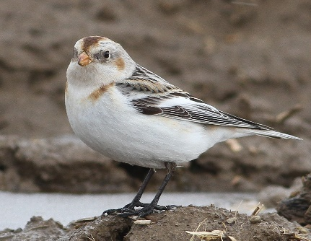

Friendly reminder: These are public roads, with both horse and buggy and vehicular traffic. We want to make a good impression on the locals by using common sense when birding the area.
==========

Comments from Matt Valencic to use on the field trip or on your own.

Meet at 9:00 AM at the west end Soltis Road at the intersection of State Route 88 south of Parkman. We will bird here and nearby Payne Road for an hour or so.

Target birds: Horned Larks (hundreds), American Goldfinch (hundreds), Lapland Longspurs (over 300 seen just before Christmas), Snow Buntings (a few mixed in with the Longspurs), possible Common Redpolls and Savannah Sparrows.
Possible showing of a Northern Harrier, Red-tailed and Cooper’s Hawks and sometimes a flyover Bald Eagle.
After Soltis, stop at the Market Express store/gas station in Parkman to use restrooms, get coffee and fuel if needed.
Next drive to Patch Road (via Tavern Road, aka Rt. 168) to look for Kestrel, Rough-legged Hawk, Northern Harrier and maybe White-crowned Sparrows below feeders at some of the farms.
Then drive to Swine Creek Reservation (9 minutes) where there are vault restrooms if needed. This is also the start of the Hayes Road segment of the trip (4 miles of slow driving and stopping). This stretch of road can yield Rough-legged, Red-tailed, Red-shouldered and Sharp-shinned Hawks, Northern Harrier and American Kestrel. Also watch fields for Horned Larks, possible E. Meadowlark and Northern Mockingbird (we will show you where it usually lives).

Directions for Parkman to Patch Road

Take Rt. 528 north for 0.2 mile, then turn left on Rt 168 (Tavern Road). Follow 168 for 3.2 miles to Patch Road. Turn right and look for parked cars.

Directions from Patch Road to parking lot at Swine Creek Reservation:
Take Newcomb Road north for 0.6 miles. Turn RIGHT on Shedd Road to Rt. 528. Left on 528 for 1.4 miles to Adams Road. Right on Adams, then a quick left onto Bridge Road.
PAGE 2.
Follow Bridge Road for 1.5 miles to Hayes Road. (Bridge ends at Hayes.)
Turn right on Hayes for about 0.4 miles to the main park entrance on the right.
Bear right at the “Y” to meet at the parking lot near the Sugar Bush when vault toilets are available.
Regroup at Swine Creek Reservation, 16004 Hayes Road, Middlefield Township, 45 minutes after leaving Soltis Road.
Watch for pheasants from the parking lot at Swine Creek to Bridge Road
Proceed north on Hayes Road for 4 miles to Peters Road, keeping the sun behind you to make it easier to scan for raptors.
Stop along Hayes Road as raptors are spotted. Also, watch feeders at houses. An Eastern Meadowlark was seen on 1/21.
When we arrive at the Fox Run School just north of Nauvoo Road, get out of cars and scan for more raptors, horned larks and snow buntings.
Two N. Mockingbirds are being reliably seen along Hayes Road, one just south of State Route 87 and the other just north of Fox Run School in a horse pasture.
This is the end the formal part of the field trip.

==============================

You can continue birding other roads in the area, return to Swine Creek Reservation for vault restrooms, or drive into Middlefield for food and warm restrooms at the Subway or Walmart.

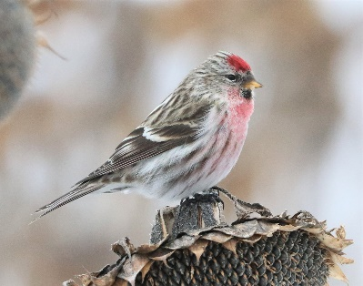

Additional roads suggested by Matt Valencic:
Peter’s Road from Hayes Road east to Bundysburg Road for raptors

PAGE 3.
Pioneer Road that is north of Peter’s Road on Rt 528 and runs east-west to Bundysburg Road. Watch for raptors and a mockingbird about half-way on the north side.
Nauvoo Road from Bundysburg to Hayes for raptors
Check the storm water pond behind the Rite Aid in Middlefield. If it's not frozen look, for Canada Geese, Mallards and Mallard hybrids. Occasionally there's something cool with them. (A few years ago Matt had a Snow Goose, Ross’s Goose and Ross’s/Snow Hybrid feeding on the grass at the same time by the apartments.)

