Jim Bissell – Kirtland Bird Club Speaker – Wednesday, June 2, 2021

James Kirk Bissell grew up on a dairy farm in Austinburg Township. A 1965 Geneva High School graduate, Jim earned a degree in plant ecology from The Ohio State University in 1969. He earned a Master of Science degree at the University of Wyoming and finished his M.S. thesis on the relationship of plants to geology within the upper Greys River in Western Wyoming.

In 2003, Jim received an Honorary Doctorate in Humane Letters from the University of Akron and received the George Fell Award in 2004 from the Natural Areas Association for lifetime achievement in natural areas preservation. In 2009, Jim was inducted into the Ohio Natural Resources Hall of Fame.

Jim was Curator of Botany at the Cleveland Museum of Natural History (CMNH), where he also served as Director of Natural Areas and was in charge of managing the Museum’s Natural Areas Program. Jim devoted his professional life to protecting the biodiversity of northeastern Ohio. Under Jim’s direction, the Museum’s preserve acreage grew from just under 1,000 acres in 1971 to 11,000 acres of unique natural habitats in northeastern Ohio, including North Kingsville Sand Barrens, the best remaining sand barren in northeastern Ohio, Geneva Swamp, the only large swamp forest remaining on the Lake Erie Lake Plain, Singer Lake Bog in Summit and Stark Counties, the finest Poor Fen glacial lake in Ohio, and several forest tracts, ranging ins size from 400 to more than 1,000 acres. During Jim’s tenure, the natural areas holdings of the Museum increased from eight to 55 preserves.

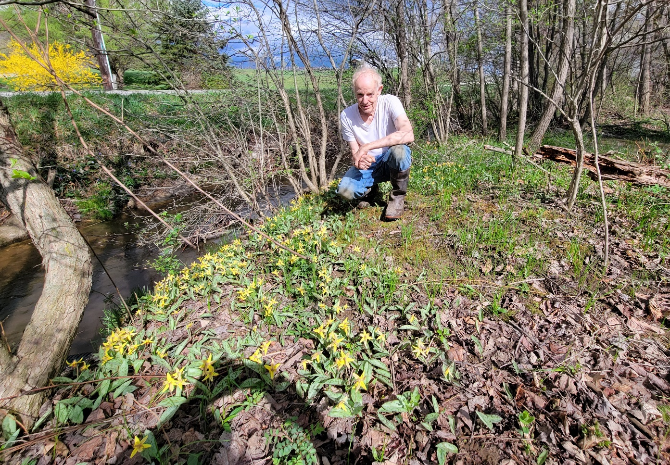
Jim Bissell at home. After he ripped out a bunch of multiflora rose and honeysuckle along the creek adjacent to our home. He says he had no idea there were trout lilies under the massive multiflora thicket! Photo by Jim Bissell’s wife.

