Recall, the goals of the CHEERS project were
- To create a community-focused resiliency plan to eastern Cleveland lakeshore that will Embrace the Lake as an asset for future generations
- To focus on leveraging nature-based solutions to improve the environment, reconnect communities to the lake, enhance public health and wellness, bolster the economy, and improve aquatic and terrestrial habitats
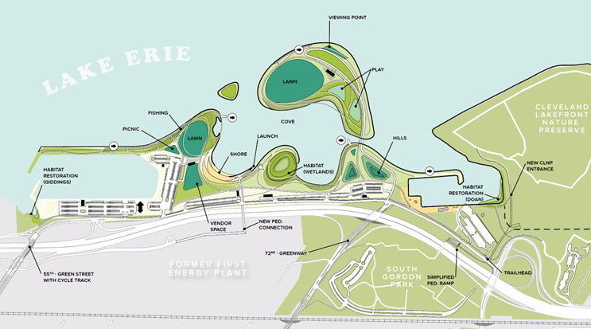
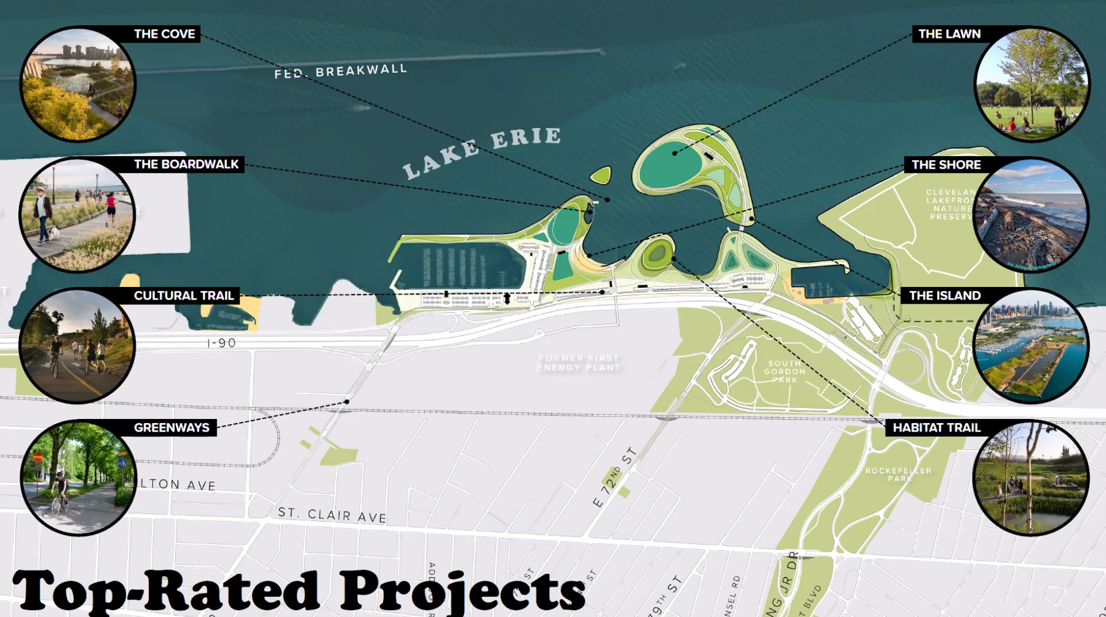
Through community engagement with stakeholders including birders, fishermen, local residents, and local community groups, the partners in the project (Cleveland Metroparks, City of Cleveland, Ohio Department of Natural Resources, Cleveland Port Authority, and Ohio Department of Transportation) the CHEERS project have created a plan for Cleveland’s lakefront. The work of creating this vision is anticipated to span the next 25 years. Currently the thought is that the first portion, new habitat, will begin in the next two years.
There’s still a little time to comment on the “FINAL CONCEPT” HERE

